Title of Invention:
A System and Method for Privacy-Preserving Real-Time Multi-Threat Detection
Using a Cascaded Neural Processing Unit Pipeline on an Edge Computing Platform

ABSTRACT
A privacy-preserving edge-AI home security system comprising a single-board edge computing host operatively coupled via PCIe to a neural processing unit, hosting a three-stage cascaded inference pipeline in which (i) a primary INT8 object detector identifies domestic threats at 52.2 FPS, (ii) a secondary binary classifier verifies weapon crops from tight bounding-box regions, and (iii) a depth-variance pre-filter flags flat-surface presentation candidates — all three stages sharing one NPU virtual device. An asynchronous, CPU-core-pinned, bounded-queue architecture structurally isolates the inference path from concurrent web, voice, authentication, and logging services, sustaining 52.26 ± 0.76 FPS across all operating modes at 5.89 W mean board power. A mode-gated alert engine with on-device Gaussian privacy blur, AES-256-CBC encrypted evidence capture, and authenticated remote access ensures no raw video leaves the device. The system achieves mAP@0.5 = 0.854 for four-class threat detection in INT8 deployment on a USD 411 hardware platform.

1. FIELD OF THE INVENTION
The present invention relates to edge-computing systems for real-time visual threat detection. More specifically, it relates to a hardware-software co-designed platform that deploys a cascaded neural processing unit (NPU) pipeline — comprising a primary object detector, a secondary classifier, and a depth-variance pre-filter — on a single low-power single-board computer, without any cloud dependency, to detect domestic threats and generate encrypted, authenticated alerts in real time.

2. BACKGROUND OF THE INVENTION
Consumer home security systems fall into two categories: (a) cloud-backed systems that stream raw video to remote data centres — forfeiting user privacy and creating data-egress risk — and (b) local single-board-computer builds limited to frame-differencing motion detection, lacking deep-learning inference, secondary verification, or encrypted evidence capture. Prior art weapon detection deployments (YOLOv4/v5/v7 on Jetson TX1, FPGA, or Raspberry Pi 4 without NPU offload) operate without a secondary verifier, depth pre-filter, privacy mode, or encrypted-evidence path. No prior art combines a multi-stage NPU cascade on one accelerator, CPU-pinned async thread isolation, on-device privacy blur, and AES-256 encrypted evidence capture within a sub-10 W single-board platform.

3. SUMMARY OF THE INVENTION
The invention is a privacy-first, edge-AI home security system comprising a Raspberry Pi 5 single-board computer, a Hailo-8L NPU (13 TOPS, INT8), and a cascaded inference pipeline implemented entirely on the edge device. Key measured outcomes:
- 52.2 FPS primary detection at 18.4 ms NPU latency.
- 52.26 ± 0.76 FPS sustained across all operating modes under full concurrent CPU-side load.
- mAP@0.5 = 0.854 for four-class domestic threat detection (INT8 deployment).
- 5.89 W mean board power under full inference + service load.
- Zero raw video egress — all inference, alerting, evidence capture, and streaming on-device.

4. PATENTABLE ELEMENTS — WHAT TO CLAIM

s4.1 Independent System Claim (Apparatus)
A privacy-preserving real-time threat detection apparatus comprising:
- A single-board edge computing host (Raspberry Pi 5) with CPU-core affinity assignment, coupled via PCIe Gen3 x1 to a dedicated NPU (Hailo-8L, 13 TOPS INT8).
- A camera sensor (Sony IMX708) on CSI-2 delivering frames to a GStreamer multimedia pipeline.
- A cascaded NPU inference engine comprising: (a) a primary four-class object detector (YOLOv8s INT8 HEF, 22.9 MB, 52.2 FPS); (b) a secondary Safe/Weapon binary classifier (MobileNetV2 INT8 HEF) on tight bounding-box crops; (c) a monocular depth-variance pre-filter (MiDaS Small INT8 HEF) as a flat-surface detection gate — all three sharing one HailoRT VDevice.
- An asynchronous bounded-queue decoupling mechanism (capacity 2, non-blocking put_nowait, intentional drop on full) between the NPU inference thread and CPU-side services.
- A CPU-core-pinned threading model: Core 0 = camera capture; Core 1 = HailoRT inference; Core 2 = secondary verifier + depth; Core 3 = OS + web services.
- A mode-gated alert engine with five operating states (DND, Email-Off, Idle, Emergency, Privacy) serialised by a threading lock.
- A privacy mode applying Gaussian blur (kernel 51 px, sigma 30 px) to every detected person bounding box before any frame delivery to display, stream, or subscriber.
- An encrypted evidence subsystem: AES-256-CBC clip encryption with SSH (paramiko) transport to a remote store.

4.2 Independent Method Claim
- Acquiring frames via CSI-2 into a GStreamer pipeline on an edge computing host.
- Dispatching frames over PCIe DMA to an INT8 NPU running a primary object detector — no CPU involvement during forward pass.
- Applying a three-consecutive-frame gate on danger-class detections; triggering alert only after 3 consecutive confirmed frames (~57.5 ms at 52.2 FPS).
- Asynchronously enqueuing tight bounding-box crops (bounded queue, capacity 2) to a secondary thread; passing crops to (a) a binary weapon classifier and (b) a monocular depth estimator; intentionally dropping crops when queue is full to protect primary inference throughput.
- Classifying person crops with depth-map variance below a fixed threshold as flat-surface candidates.
- Applying Gaussian privacy blur on person bounding boxes in privacy mode before output.
- On confirmed danger: asynchronously fan-out to (a) WebSocket push, (b) SMTPS email with per-label 60 s cooldown, (c) AES-256-CBC encrypted clip upload via SSH — all off the inference thread.

4.3 Key Dependent Claims
Claim | Limitation Added
DC-1 | Primary detector compiled to INT8 HEF (22.9 MB) via post-training quantisation with 128 calibration images; normalisation embedded in HEF graph. mAP@0.5 = 0.854 on held-out test split.
DC-2 | Three HEF models share one HailoRT VDevice via sequential time-shared infer calls; combined secondary-stage latency per crop < 4 ms.
DC-3 | Per-label SMTPS alert cooldown of 60 seconds prevents alert flooding on sustained detections.
DC-4 | Deadman watchdog polls inference heartbeat every 10 s; triggers restart after 180 s silence.
DC-5 | Presence monitor uses ARP scanning at 30 s intervals with 90 s grace window to detect occupant devices and switch operating modes.
DC-6 | Authentication: PBKDF2-SHA256 at 600,000 iterations, per-user salt, HTTP-only session cookie; admin 2FA via 6-digit OTP over SMTPS, 10-minute expiry.
DC-7 | Asymmetric confidence thresholds: 0.60 for Person (watch class), 0.25–0.35 for weapon classes (alert classes).
DC-8 | Voice assistant transcribes locally; only text transcript (never audio/video) is sent externally as a stateless JSON-constrained LLM completion when no local rule matches.
DC-9 | Events drained off-thread to append-only text, JSON, and SQLite store; catch-up REST endpoint /api/events?since=T without unbounded server buffering.
DC-10 | Mean board power under full concurrent load: 5.89 ± 1.43 W; NPU surface temperature rise: +3.8°C above ambient idle.

5. CHANGES NEEDED BEFORE FILING

5.1 Mandatory
- Have a patent attorney formally draft all claims in numbered format with 'comprising', 'wherein', 'configured to', 'operatively coupled' language.
- Every method claim must reference at least one physical hardware element (NPU, camera, PCIe bus, edge host) — no pure software claims.
- Independent claims should be broad (any NPU + single-board + cascaded pipeline). Dependent claims add the specific Hailo-8L / Pi 5 / YOLOv8s details.

5.2 Do NOT Remove (these are the novel claims)
- Bounded-queue + intentional-drop design — key differentiator from prior art.
- Three-consecutive-frame gate — explicitly claim this timing mechanism.
- Asymmetric confidence thresholds (0.60 Person / 0.25 weapons) — claim as method step.
- AES-256-CBC + SSH evidence path — not present in any cited prior art.
- On-device Gaussian blur in privacy mode — no prior art has this as a system feature.

5.3 Optional Strengthening (for Complete Specification later)
- Add a proper face anti-spoof stage when implemented — add as a dependent claim.
- Add the iOS/macOS SwiftUI companion app as an optional embodiment.
- Add temporal activity recognition layer as a method extension claim.

6. DETAILED METHODOLOGY

6.1 Hardware Architecture
The System is deployed on a Raspberry Pi 5 (BCM2712, quad-core Cortex-A76, 2.8 GHz overclocked, 16 GB LPDDR4X-4267, Raspberry Pi OS Debian 12, Linux 6.12.x). A Hailo-8L AI HAT+ on the PCIe Gen3 x1 M.2 slot provides 13 TOPS INT8. Video: Raspberry Pi Camera Module v3 (Sony IMX708) via CSI-2. Storage: 1 TB SATA SSD (USB 3.0). Network: 802.11ac Wi-Fi. Total BOM: USD 411 / INR 38,085.
Component | Specification
Host SoC | BCM2712, Cortex-A76 @ 2.8 GHz (overclocked)
RAM | 16 GB LPDDR4X-4267
NPU | Hailo-8L AI HAT+ — 13 TOPS INT8, PCIe Gen3 x1
Camera | Raspberry Pi Camera Module v3 (Sony IMX708, CSI-2)
Storage | 1 TB Crucial SATA SSD, USB 3.0 enclosure
Network | 802.11ac Wi-Fi
Power | 5 V / 5 A USB-C; 5.89 W mean under full concurrent load
NPU Interface | PCIe DMA — no CPU involvement during forward pass

6.2 System Block Diagram
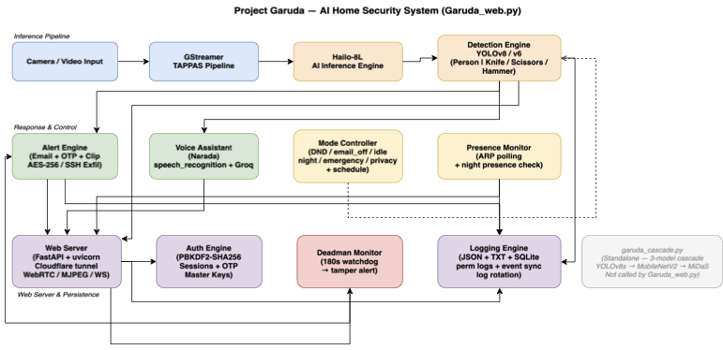
Figure 1 — Three-layer system block diagram

6.3 End-to-End Runtime Flowchart
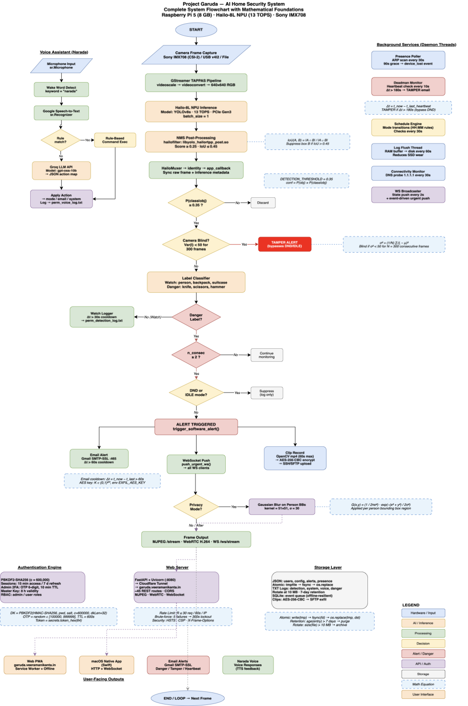
Figure 2 — End-to-end runtime path of a danger detection event

6.4 Hardware Topology
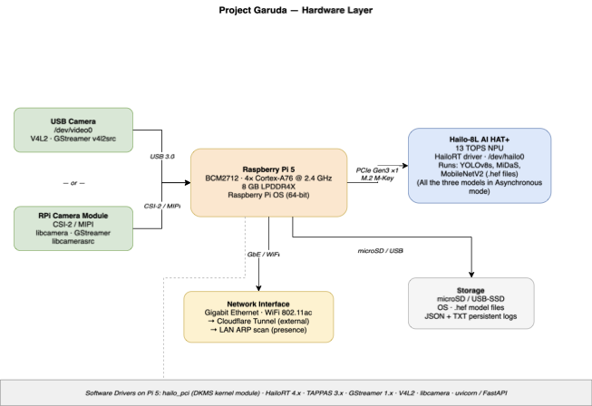
Figure 3 — Hardware topology (Pi 5, Hailo-8L, Camera v3, SSD)

6.5 GStreamer TAPPAS Pipeline Engine
The pipeline extends the Hailo TAPPAS GStreamer framework. A libcamerasrc element captures frames; videoscale/videoconvert letterbox-resizes to 640x640. The pipeline forks: the inference branch dispatches to the Hailo-8L via HailoNet (NMS: IoU 0.45, confidence 0.35) in a HailoFilter; a bypass branch holds the raw frame in a queue. HailoMuxer re-aligns both. An identity element exposes the buffer to the application callback as a pad probe. HailoOverlay renders annotated output.
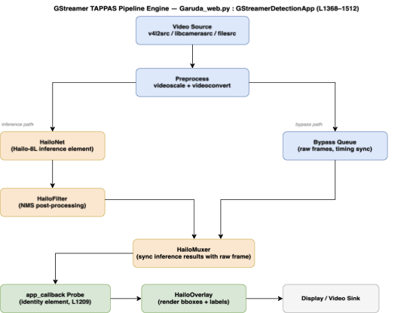
Figure 4 — GStreamer TAPPAS pipeline topology

6.6 Three-Stage Cascade Inference Engine
Stage 1 — Primary Detector (YOLOv8s, INT8):
YOLOv8s fine-tuned on a four-class corpus (Hammer, Knife, Person, Scissors; 6,226 images, 5,311 instances) and compiled to a 22.9 MB INT8 HEF via Hailo DFC v3.33.1 (128 calibration images; normalisation embedded in HEF graph). Performance: mAP@0.5 = 0.854, mAP@0.5:0.95 = 0.682 on held-out test split (within +0.007 / +0.012 of FP32). Throughput: 52.2 FPS at 18.4 ms NPU latency. Confidence thresholds: 0.60 (Person), 0.25–0.35 (weapon classes).
Stage 2 — Secondary Weapon Verifier (MobileNetV2, INT8):
Each weapon-class crop (224x224 tight bounding-box) is classified as Safe or Weapon. Fine-tuned: 5 head-only epochs + 35 full epochs (AdamW, focal loss gamma=2.0). Accuracy: 99.0% on 500-crop balanced held-out set (95% Wilson CI [97.7%, 99.6%]). Runs at 500+ FPS in isolation; adds <2 ms per-frame.
Stage 3 — Depth-Variance Pre-Filter (MiDaS Small, INT8):
For person crops (256x256), MiDaS Small generates a normalised monocular depth map. If depth variance < 0.005, crop is flagged as a flat-surface candidate (photo/screen). Calibrated: real persons = 0.022–0.10, flat screens < 0.005. Runs at 200+ FPS in isolation; adds <5 ms. End-to-end cascade: 22–27 ms.
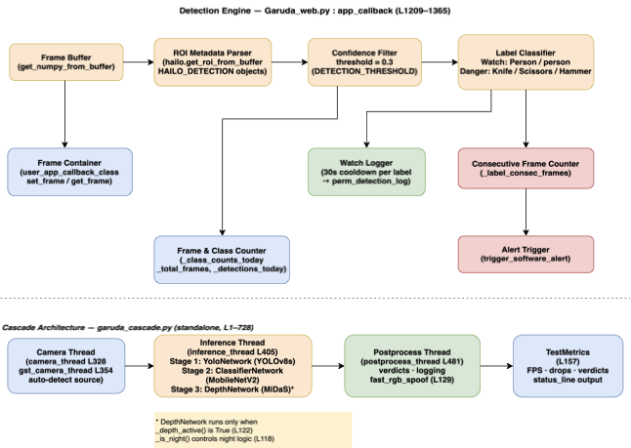
Figure 5 — Cascade inference pipeline and decision flow

6.7 Asynchronous CPU-Core-Pinned Architecture
Thread-to-core affinity is pinned via os.sched_setaffinity, bounding scheduler jitter. The NPU inference thread (Core 1) and the secondary chain (Core 2) are decoupled by a bounded queue (capacity 2, non-blocking put_nowait; intentional drop when full). A separate frame_queue (depth 4, drop-if-full) decouples the NPU from web/alert services. Empirical result: 52.26 ± 0.76 FPS (n=709, CV=1.45%) across 6 modes under full concurrent load (SMTP, SSH clip upload, voice queries, MJPEG stream — 583 MB transferred).
Core | Assigned Thread | Task
Core 0 | Camera capture | libcamerasrc frame acquisition via CSI-2
Core 1 | HailoRT inference | Primary YOLOv8s detection, NMS, bounding-box output
Core 2 | Verifier + depth | MobileNetV2 crop classification, MiDaS depth variance
Core 3 | OS + FastAPI | Web server, auth, logging, voice assistant, watchdog

6.8 Three-Consecutive-Frame Danger Gate
Weapon-class detections increment a per-label consecutive-frame counter. Alert fires only when the counter reaches 3 without interruption — suppressing single-frame false positives while triggering within 3/52.2 ≈ 57.5 ms of a genuine threat. Weapon counters per class are independent.

6.9 Mode-Gated Alert Engine
Mode | Behaviour
Normal / Active | Full fan-out: WebSocket push + SMTPS email + AES-256 SSH clip upload
Emergency | Same as Active; all suppression rules lifted
Privacy | Alert fires; person bounding boxes Gaussian-blurred (k=51 px, σ=30 px) on all output frames
Do Not Disturb | WebSocket push only; SMTP and SSH suppressed
Idle | Alert engine short-circuited; detection continues silently

Fan-out is asynchronous — SMTP (~800 ms) and SSH execute off the inference thread; the 18.4 ms NPU budget is unaffected.
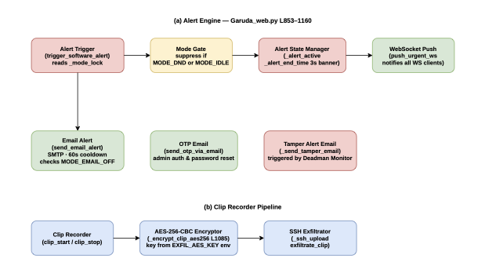
Figure 6 — Alert engine fan-out dataflow

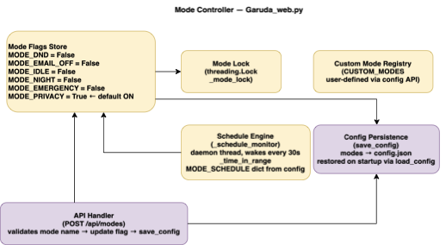
Figure 7 — Mode controller state diagram

6.10 Authentication and Remote Access
FastAPI web server (Uvicorn, localhost:8080) exposed via Cloudflare Tunnel. Authentication: PBKDF2-SHA256 at 600,000 iterations, per-user salt, HTTP-only session cookie. Admin 2FA: 6-digit OTP via SMTPS, 10-minute expiry. ~45 REST routes with route-level role checks. Live-video: MJPEG, WebSocket binary, WebRTC (aiortc).
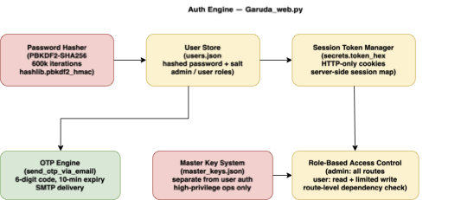
Figure 8 — Authentication and web server architecture

6.11 Presence Monitor and Deadman Watchdog
Presence monitor: ARP scanning at 30 s intervals with 90 s grace window detects any device holding a valid IP lease (including phones in pocket-sleep). Deadman watchdog: polls inference heartbeat every 10 s; triggers restart after 180 s silence.
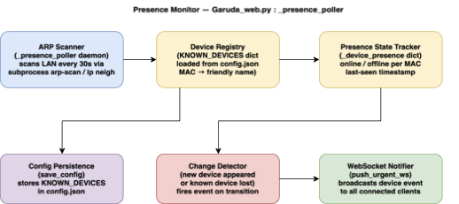
Figure 9 — Presence monitor and deadman watchdog flow

7. KEY PERFORMANCE RESULTS
Metric | Value
Primary detector throughput (NPU) | 52.2 FPS
Primary detector latency (NPU) | 18.4 ms
mAP@0.5 (INT8, held-out test split) | 0.854
mAP@0.5:0.95 (INT8) | 0.682
FP32 vs INT8 delta | +0.007 / +0.012 (INT8 higher)
Sustained FPS under full concurrent load | 52.26 ± 0.76 FPS (n=709, CV=1.45%)
Detect-to-decision (end-to-end cascade) | 22–27 ms
MobileNetV2 accuracy (in-distribution) | 99.0% (95% CI [97.7%, 99.6%])
Open-set specificity (household clutter) | 1.000 (301/301 clutter crops → Safe)
Mean board power (full load) | 5.89 ± 1.43 W (peak 8.58 W)
NPU surface temp rise (90 s run) | +3.8°C above ambient idle
HEF file sizes | 22.9 MB (YOLOv8s), 7.1 MB (MobileNetV2), 35 MB (MiDaS)
Total BOM | USD 411 / INR 38,085

8. ABSTRACT (for Provisional Filing)
A privacy-preserving edge-AI home security system comprising a single-board edge computing host operatively coupled via PCIe to a neural processing unit, hosting a three-stage cascaded inference pipeline in which (i) a primary INT8 object detector identifies domestic threats at 52.2 FPS, (ii) a secondary binary classifier verifies weapon crops from tight bounding-box regions, and (iii) a depth-variance pre-filter flags flat-surface presentation candidates — all three stages sharing one NPU virtual device. An asynchronous, CPU-core-pinned, bounded-queue architecture structurally isolates the inference path from concurrent web, voice, authentication, and logging services, sustaining 52.26 ± 0.76 FPS across all operating modes at 5.89 W mean board power. A mode-gated alert engine with on-device Gaussian privacy blur, AES-256-CBC encrypted evidence capture, and authenticated remote access ensures no raw video leaves the device. The system achieves mAP@0.5 = 0.854 for four-class threat detection in INT8 deployment on a USD 411 hardware platform.

